Nama : Rima Natalia

Kelas : XII RPL 2

Doc. : Screenshoot hasil kerja

1. **Sidebar**

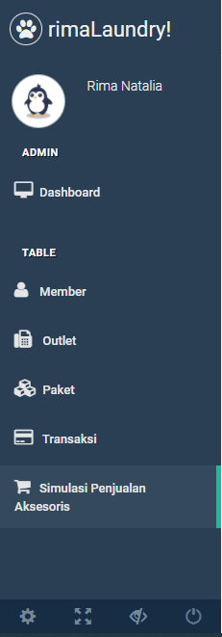

1. **Tampilan Form**

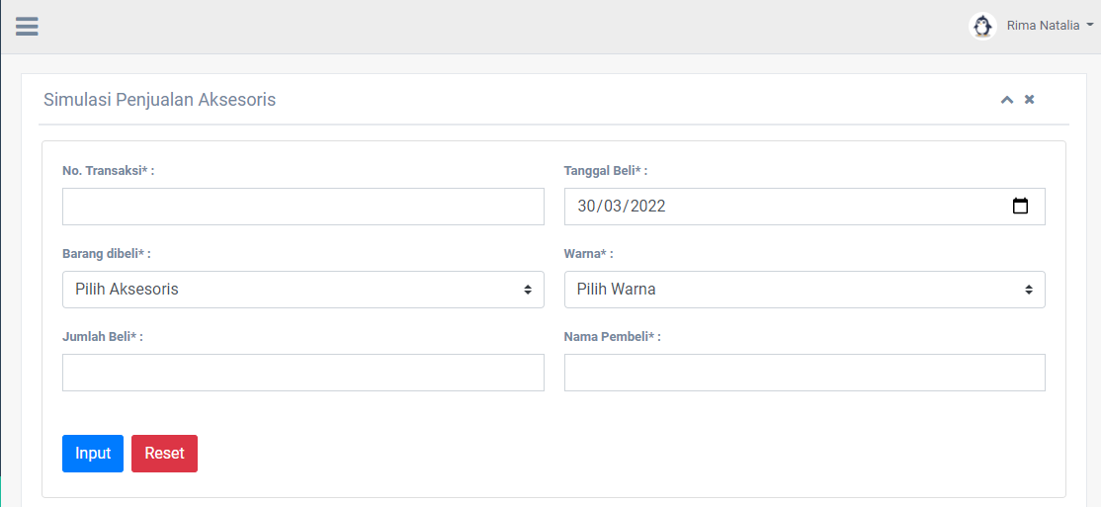

1. **Tampilan Data**

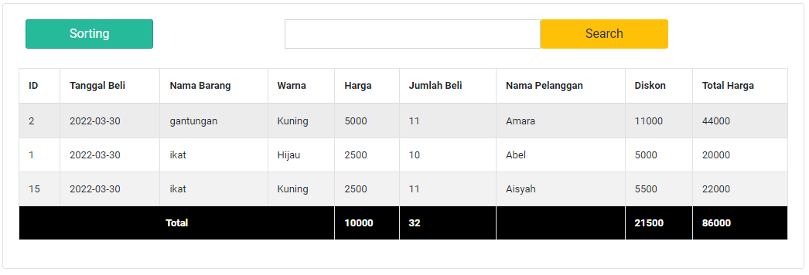

1. **Sorting**

**(From This)**

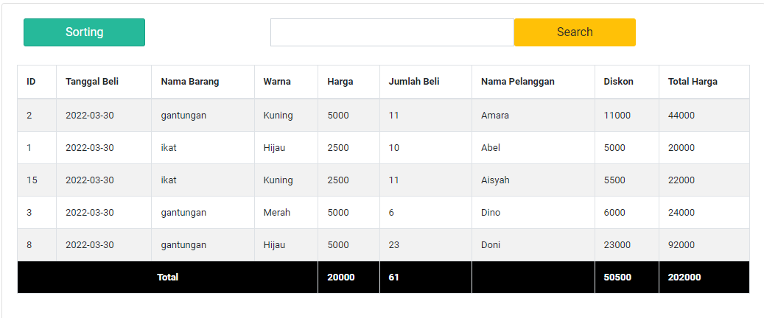

**(To This)**

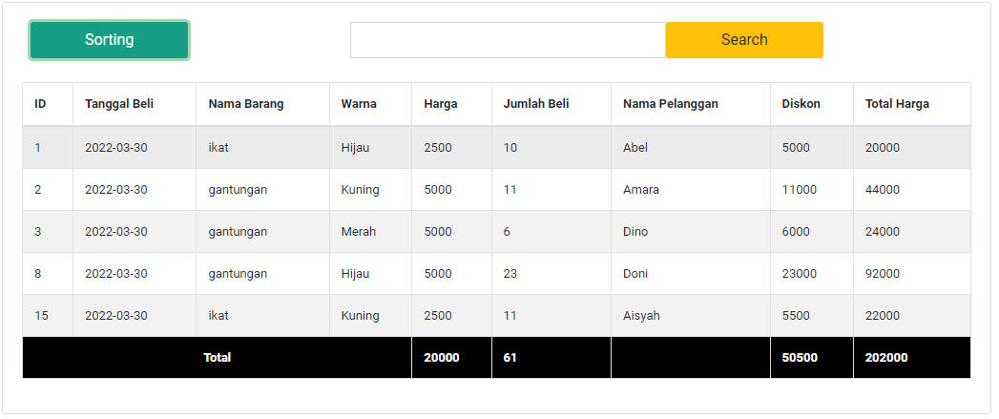

1. **Searching**

